SANCTUARY LAMP- For the week of October 19th – 25th the Tabernacle Sanctuary Lamp will burn for the repose of the soul of Richard Dean Philpott. If you would like to have the Sanctuary Lamp lit for a deceased relative or friend or for a special intention, contact the parish office. The cost is $5.00 per week.

PRAYERS FOR OUR SICK - Lord hear our prayer for those who are sick, recovering from surgery, aging and in need of our prayers, and for those who care for them, may they find strength and courage through their faith. We pray for John Power, Michael Grace, Ashley White, Lorraine Hearn, Brendan Grace, Jenny Hickey, Delores Smith, Tony Grace & John Tucker. If you would like to have your loved ones prayed for please call the parish office.

TWO DAY RETREAT WITH FATHER MARK CHERRY OF SACRED HEART EVANGELIZATION AND HEALING MINISTRY: We are very pleased to announce a retreat weekend and Healing Mass with Father Mark Cherry from the Diocese of Halifax-Yarmouth. The retreat will be held at Our Lady Queen of Families in Mt. Pearl on Friday October 24th from 6-9 p.m. and Saturday October 25th. from 8:30 a.m.-3:00 p.m., returning on Saturday evening at 6 p.m. Father Mark Cherry will be giving four dynamic teachings-Understanding the Kingdom, The Fruit of The Kingdom, The Power of the Kingdom and The Coming Fullness of The Kingdom. Coffee, refreshments and lunch will be provided on Saturday. Registration fee- $55.00. Please contact Suzanne Rowe for information and registration: 709-727-5809

33 DAYS TO MORNING GLORY RETREAT -St. Edward’s Parish is offering Stage One of the Hearts Afire Program, 33 Days to Morning Glory retreat beginning Saturday, November 1, to December 6, 2025. The group will meet once per week on Saturday from 10:30am to 12:00 noon. This is a parish-based program from the Marion Fathers of the Immaculate Conception that will include readings, a video, and group discussion. 33 Days to Morning Glory prepares for consecration to Jesus through Mary, and the consecration will take place on Dec. 8th the Feast of the Immaculate Conception. To register contact the parish office (709) 834-9481 or Marguerite Greene (709) 773-1237.

WORLD MISSION SUNDAY – Today is World Mission Sunday and every Catholic Community and parish throughout the world is involved in this event. This is a day when we show that we all missionary disciples who have a role to play in spreading the Gospel message. The financial donation you offer today will assist missionary priests, sisters and catechists throughout the world to spread the Gospel. Thank you for support the missions with your prayers and donations.

CATHOLIC WOMEN’S LEAGUE FOOD DRIVE – St. Thomas of Villanova CWL will be collecting food for the CBS/Paradise Community Food Bank. Any food items will be greatly appreciated and can be dropped off in the box located at the entrance of the church until
October 19th. Thank you for your support.
ST. EDWARD’S PARISH FALL FAIR - is scheduled for Sunday, November 16th,
1:30 to 5:00 pm at St. Edward's Parish Hall. Many events: Goods Spin Wheel, Crafts, Baked Goods, Cake Auction, Bottle Table, Children's Games of Chance, Cake Walk, Ladies Purse and Jewelry table, 50/50 Tickets and Canteen. There will be a Door Prize. Donations needed for the Goods Spin Wheel -value $20 to $25. Cakes for the Cake Auction and Cake Walk. Volunteers are needed to help with booths and events. Please add your name to the volunteer list available at weekend Masses. Please come out and support your Parish.
CAKE WALK: $1 to play, numbers are on the floor, move to music around the floor for your chance to win a cake. There will be 15 numbers.
CAKE AUCTION: Cakes will be available on a table, purchase your tickets and drop your ticket in the box in front of the cake you would like to win. Numbers will be drawn at the end of the fair.
MASS SCHEDULE October 14 - 19 INTENTION
Tues. Oct. 21 10am +Vince Burton - +Ronald Maher - +Bessie Nugent
Wed. Oct. 22 10am +Mitchell Crotty -+Josephine White - +Joseph Christopher
(St. John Paul 11)
Thurs. Oct. 23 10am +Bernard Lewis -+John Noseworthy -+David Warren
(St. John of Capistrano)
Fri. Oct. 24 7pm SI – J.M. – SI –Pat Hynes –SI – Lou Salvador
(St. Anthony Mary Claret)
Sat. Oct. 25 4pm +Francis & Cecilia Johnson -+William Tucker/Florence Curran/Anne & Stephen Parsley/Rose & Charl Butler -+CWL
Sun. Oct. 26 10:30 am All Parishioners
(30th Sunday in Ordinary Time)
Note: + = Deceased S.I. = Special Intentions

Confession times will be as follows:
Wednesdays 10:30am – 11:00 am
Saturdays: 2:15pm–3:45pm
Sundays: 9:30am–10:00am

Prayers for Special Intentions during Jubliee 2025 Pilgrimage to Rome - Doreen Dray, of St. Edward's Parish, will be joining the Pilgrimage from the Basilica Parish on Nov. 5, 2025.
There will be a small notebook, identified by the Pilgrimage logo on the cover, placed at the back of the church. Parishioners and friends are invited to write in the notebook any Special Intentions that they would like included in prayers at the various shrines and churches visited during the Pilgrimage. She will be taking this notebook with her as she travels and including these intentions as she prays during this special and holy event.

PARISH COLLECTIONS October 11 & 12
Fund # of envs. Amount Loose Total
Sunday offering env. 117 $1,965.00 $418.25 $2,383.25
Dues 3 $ 145.00 $ 145.00
Food bank env. 3 $ 20.00 $ 20.00
Fall Fair env. 27 $ 549.70 $ 549.70
Maintenance off. env. 1 $ 25.00 $ 25.00
Evang. of Nations env. 3 $ 40.00 $ 40.00
Students to the Priesthood 2 $ 30.00 $ 30.00
Donation to Heat Pumps 4 $ 580.00 $ 580.00
Totals 160 $3,354.70 $418.25 $3,772.95
Received with deep appreciation and gratitude.

UPCOMING MEETINGS:
Finance Council - Tuesday, October 21st – 7:00pm
Knights of Columbus Wednesday, October 29th – 7pm

K of C Blessed Trinity Council # 6792 is selling a K of C State ticket –Tickets are $2.00 each or 3 for $5.00. Those interested in purchasing tickets can contact Jim Woodrow, G.K. at
709-773-0010 or Len Furlong 709- 834-3842. 1st prize $5,000.00, 2nd $1,000.00 & 3rd $500.00.

CENTRE FOR LIFE ONLINE AUCTION – Oct. 20th – 12pm – Oct. 25th – 12pm.
To join the auction, visit our Facebook group www.facebook.co/groups/centreforlifeauction or follow the line on our homepage at
www.centreforlife.ca Lots of great items and gift ideas. Donations accepted up to October 17th call 709-579-1500.

MINISTRIES
Saturday, Oct. 25 - 4:00 PM - CWL Sunday, October 26 - 10:30 AM
1st R - Trudy Strowbridge 1st R - Brendan Murphy
2nd R - Doreen Dray 2nd R & IP - Myrna Power
IP - Barb McGrath Usher - Paul Kelly – Tracy Barron
Usher - Daisy Carroll/Bernie Browne OFF - Gertie Kielly
OFF - Margaret Fitzpatrick/Geralyn Murray EM - Doreen Dray
EM Lorna Clark S - Steve Dray
S - Rita Locke

TWENTY-NINTH SUNDAY IN ORDINARY TIME
OCTOBER 19, 2025

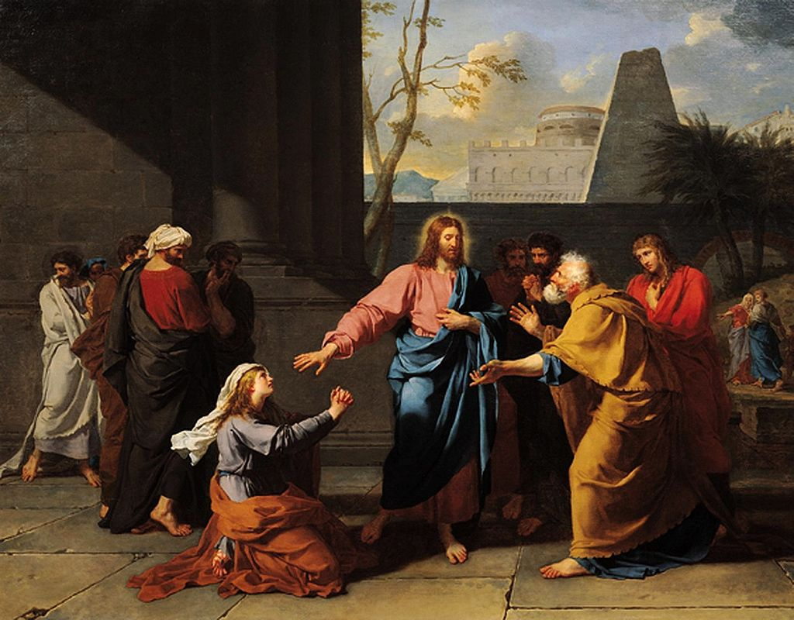

WELCOME TO ST. EDWARD’S PARISH
2696 Topsail Road, CBS
Box 13048, Topsail Station
CBS, NL A1W 2K1
834-9481
Email – Stedwardsparish@outlook.com
Website –https://stedwardsparishweb.wixsite.com/st-edwards-parish-nl

Parish Priest – Fr. James Fleming
Administrative Assistant – Jennifer Hutchings
Parish Council Chair – Dave Locke
Liturgy Committee Chair – Monika Behr
Finance Council Chair – Paul Kelly

OFFICE HOURS
Monday – Friday – 8:30 am – 4:30 pm
Closed daily 12 -1pm

